CMS

Building a powerful plane using a Arduino flight controller.

Arduino plane building.

*Content –*

**1.** Parts required.

**2.** Assembly.

**3.** PCB and bread board design.

**4.** Software installation.

**5.** Maiden flight.

**Parts required**

|  |  |
| --- | --- |
| Items Required. |  |
| Foam sheet 3x  Servo motor 4x  Brushless motor 1x  ESC 1x  Radio transmitter 1x  Propellers 1x  Arduino nano 1x  PCB 1x  Metal wires 5x |  |

You can purchase all the products from here…

**Foam sheet from** [**here**](https://www.amazon.in/Vibhuti-Crafts-Sunbaord-Projects-School/dp/B089KDD43X/ref=pd_sbs_229_1/260-5008124-3247533?_encoding=UTF8&pd_rd_i=B089KDD43X&pd_rd_r=4f24ee37-6f33-45a1-bebc-846c900201d2&pd_rd_w=f60WF&pd_rd_wg=Eb4m9&pf_rd_p=758bfbc8-a8f2-4456-bf65-ae5d502eac06&pf_rd_r=QKA86ASRZS6E2XCYCVRM&psc=1&refRID=QKA86ASRZS6E2XCYCVRM)

**Servo motor from** [**here**](https://robu.in/product/towerpro-sg90-continuous-rotation-360-degree-servo-motor/)

**Brushless motor from** [**here**](https://robu.in/product/a2212-10t-13t-1000kv-brushless-motor-with-soldered-connector/)

**ESC from** [**here**](https://robu.in/product/30a-bldc-esc-electronic-speed-controller/)

**LiPo battery from** [**here**](https://robu.in/product/orange-11-1v-1500mah-3s-30c-lipo-battery-pack-xt60-connector/)

**Radio transmitter from** [**here**](https://robu.in/product/ct6b-flysky-2-4ghz-6ch-transmitter-wfs-r6b-receiver-mode-2/)

**Propellers from** [**here**](https://robu.in/product/orange-hd-propellers-60306x3-0-glass-fiber-nylon-1cw1ccw-1pair-grey/)

**Arduino nano from** [**here**](https://robu.in/product/arduino-nano-board-r3-with-ch340-chip-wo-usb-cable-solderedarduino-nano-r3-wo-usb-cable-soldered/)

**PCB – see the further document.**

**Metal wires from any hardware store.**

**Assembly**

Now, there is no certain rule for the design and the assembly of the RC plane, but you can follow this video to make a stylish body –

**NOTE:** The body of the plane should be equipped with one propeller,

In order to make the plane told in this guide.

[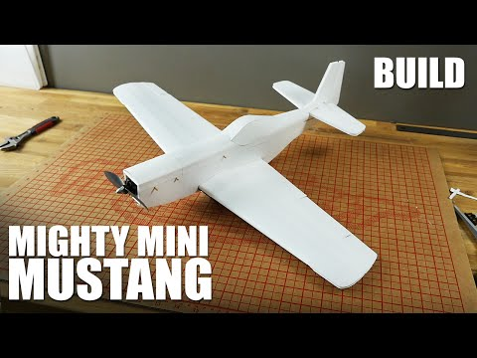](https://www.youtube.com/embed/ov_Nm64YMpk?feature=oembed)

**PRO TIP:** Building a plane at your own gives you the best idea, and you can make your dreams come true.

Still, you can follow the video above by *‘Flight test’* , make sure to check out their YT.

PCB and Bread board design.

Please visit our website for bread board and circuit design,

The function and our other projects are given there

Please visit our site from [here.](http://cmsplanes.ezyro.com)

CMS Technology for everyone.

By – Prasoon rai

Partners – Medieval airlines.



Software Installation

Now, before the installation of the software you need to understand that, how to use the software provided to you by us.

Please follow these steps from install Arduino IDE to running the software.

* 1. Installing Arduino IDE.

Please go to [arduino.cc](https://www.arduino.cc/en/software) to install the software for your OS.

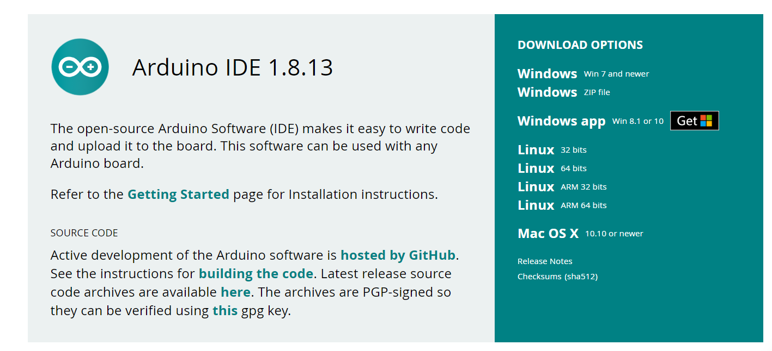

2. Now after install the Arduino IDE software it will look like this.

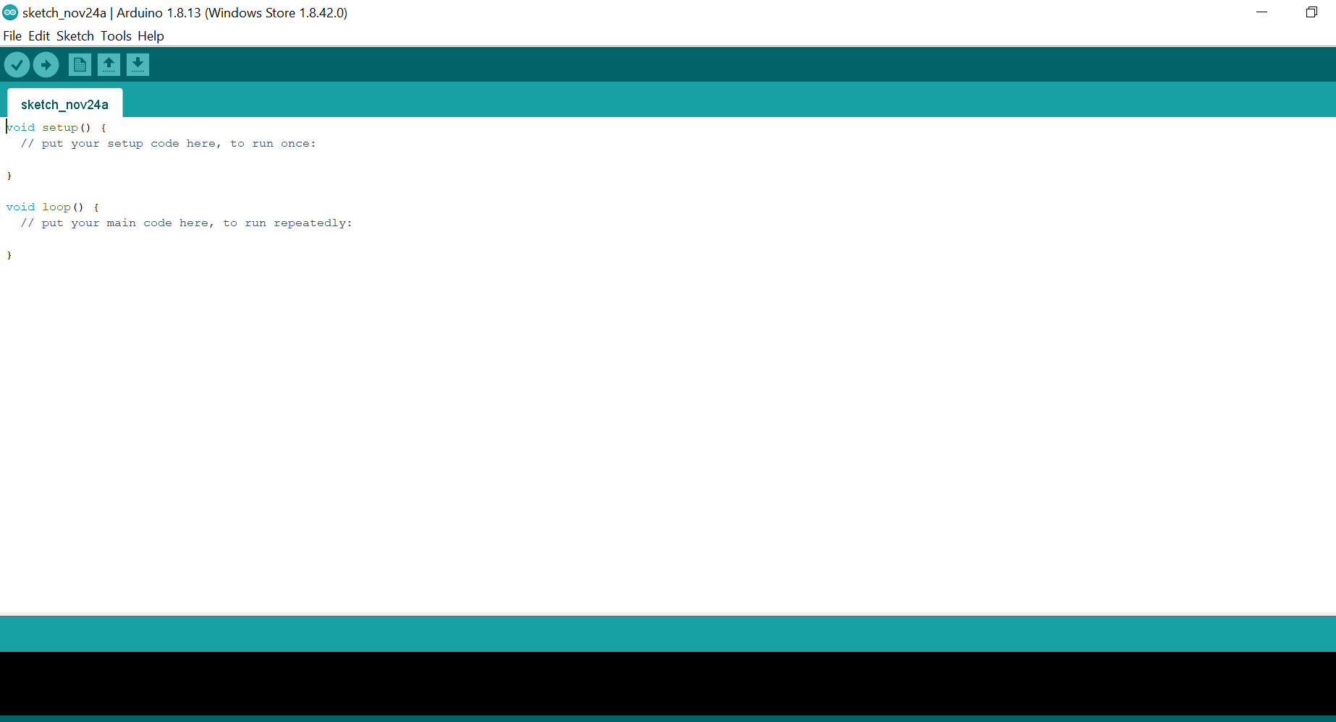

Now, if you see such a screen this means that your installation was successful.

3. Now from our [website](http://cmsplanes.ezyro.com) download this [file.](https://www.dropbox.com/sh/wgmngclwg6s1qdz/AAC_BMQ7VspLsULb66Sjdd23a?dl=0)

Page will look something like this.

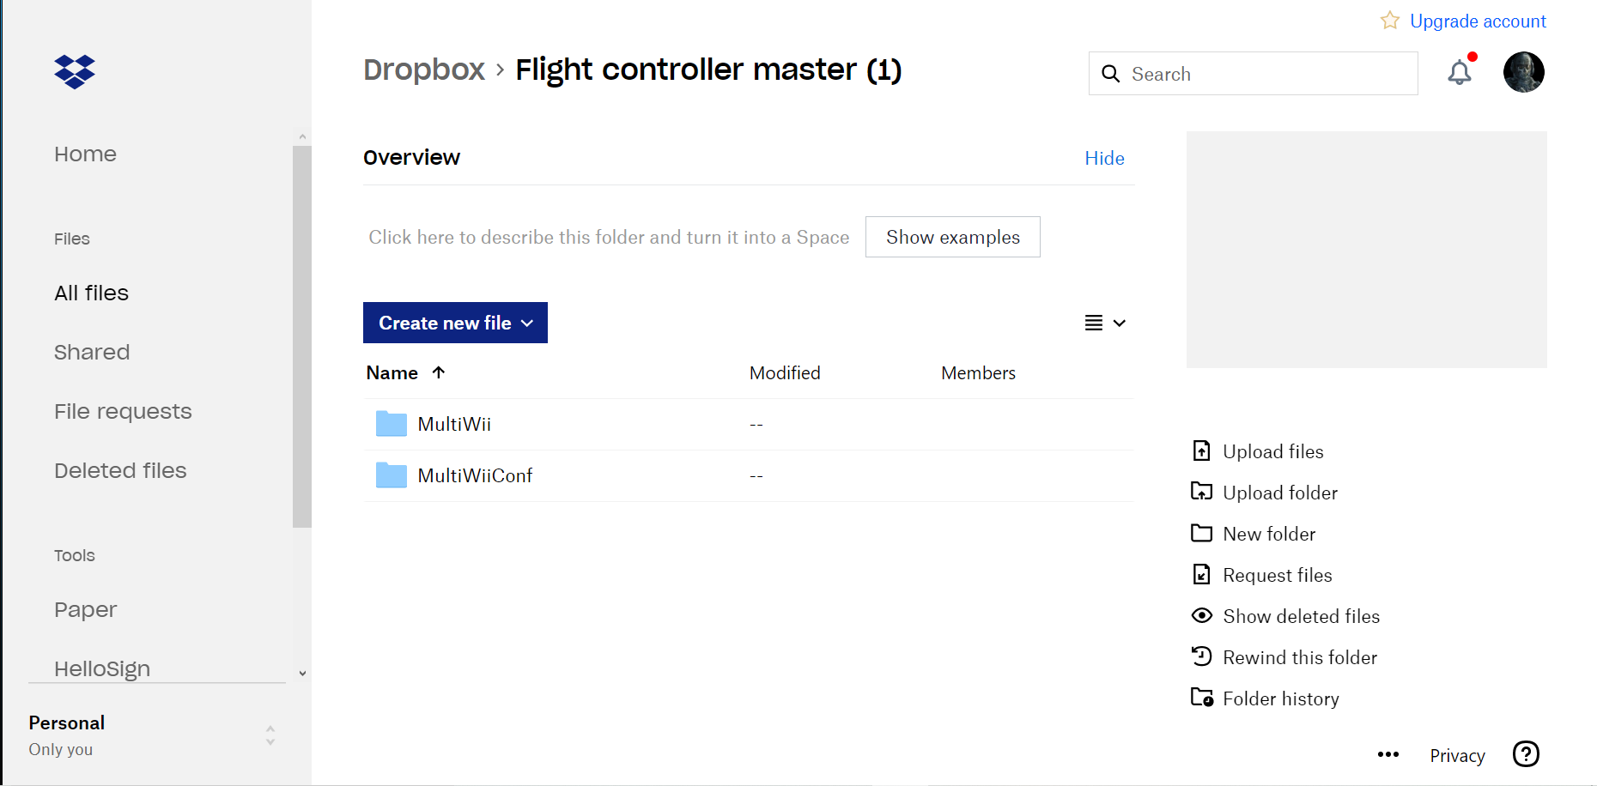

However, if there is some difference, please download it.

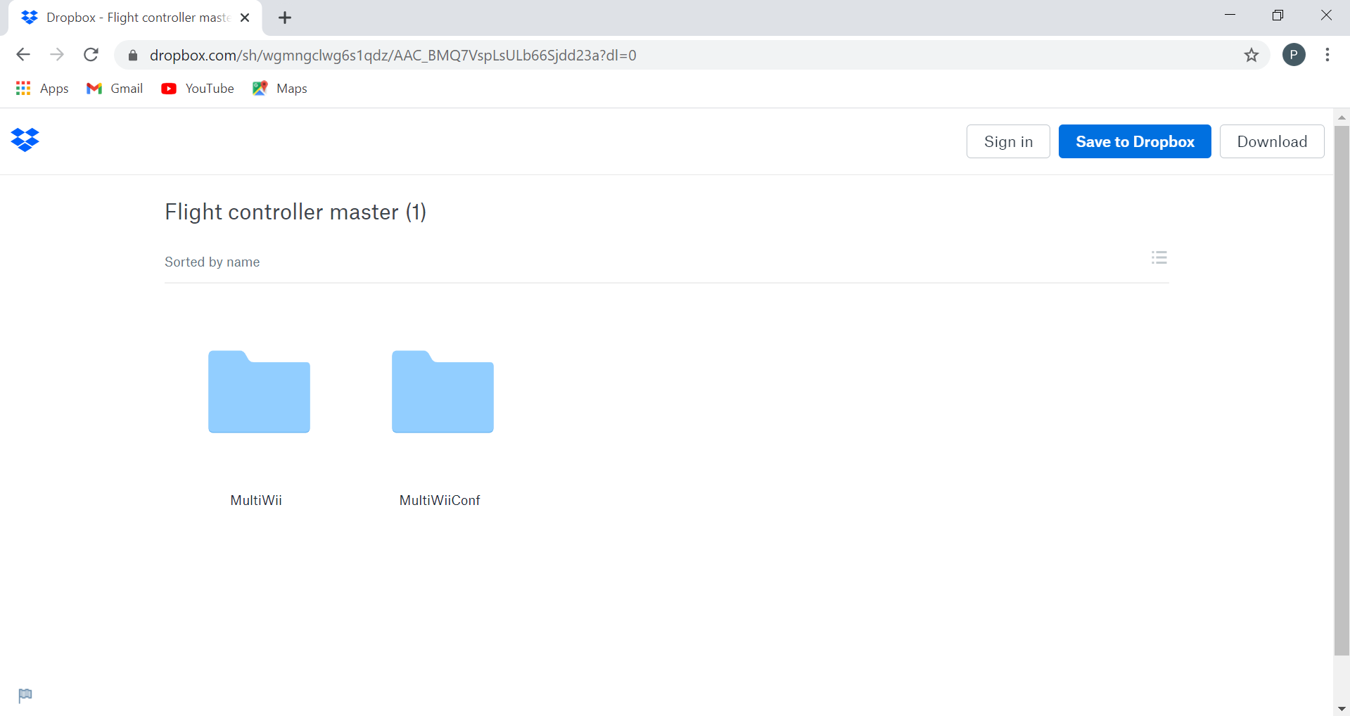

It will look like this one.

4. Now open the download file in your folder.

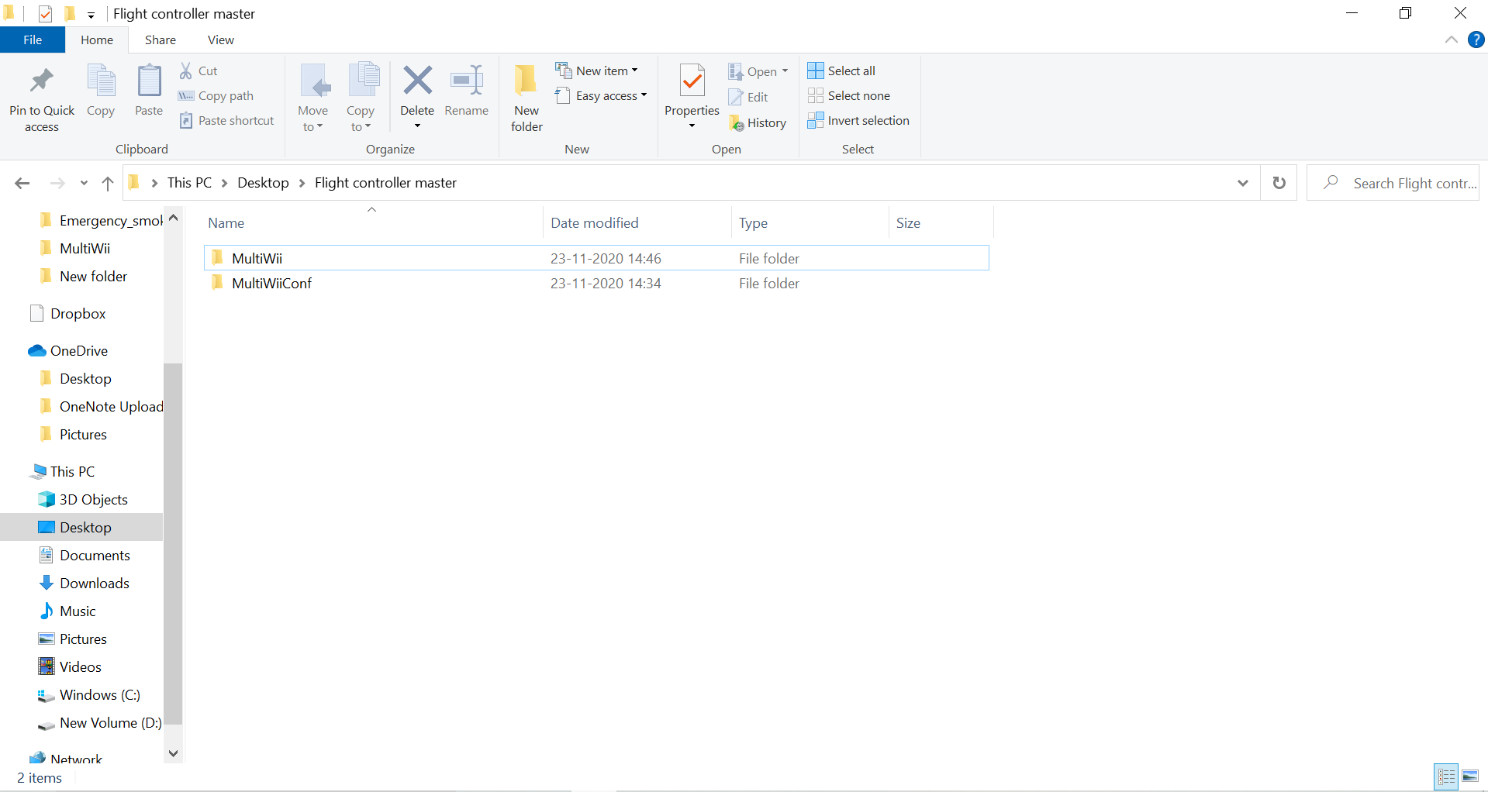

Now first lets open the folder named *‘MultiWiiConf’*

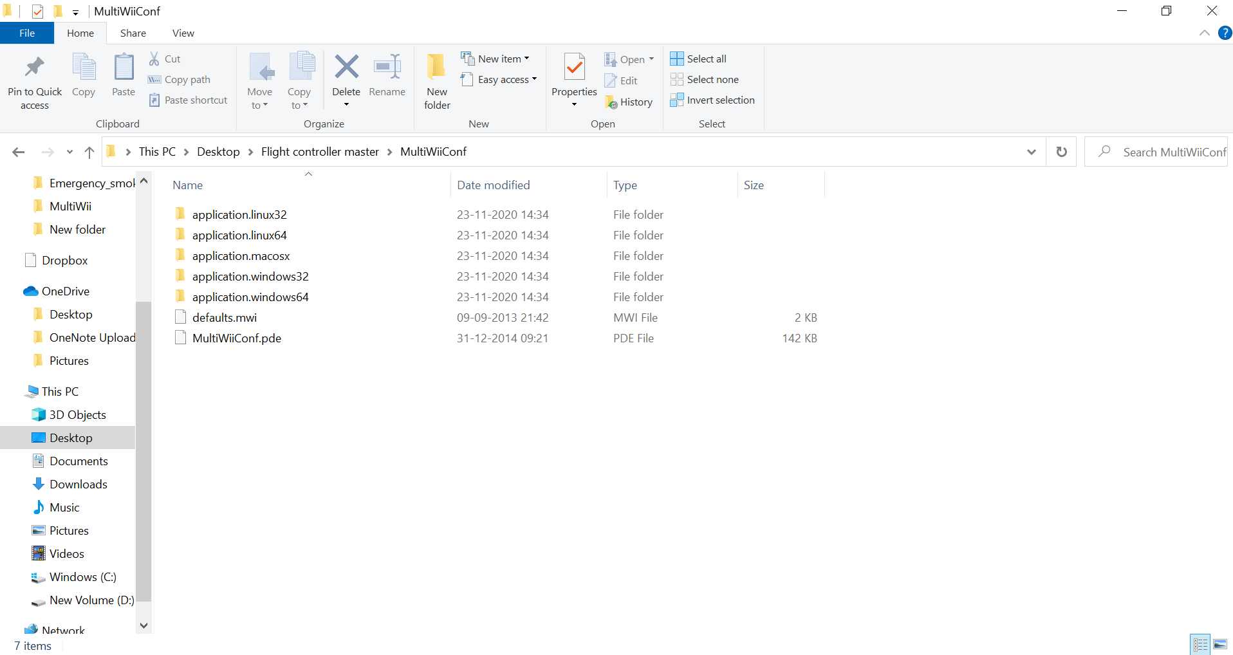

Now open the folder for your OS. In mine case it is Windows with a 64 bit machine.

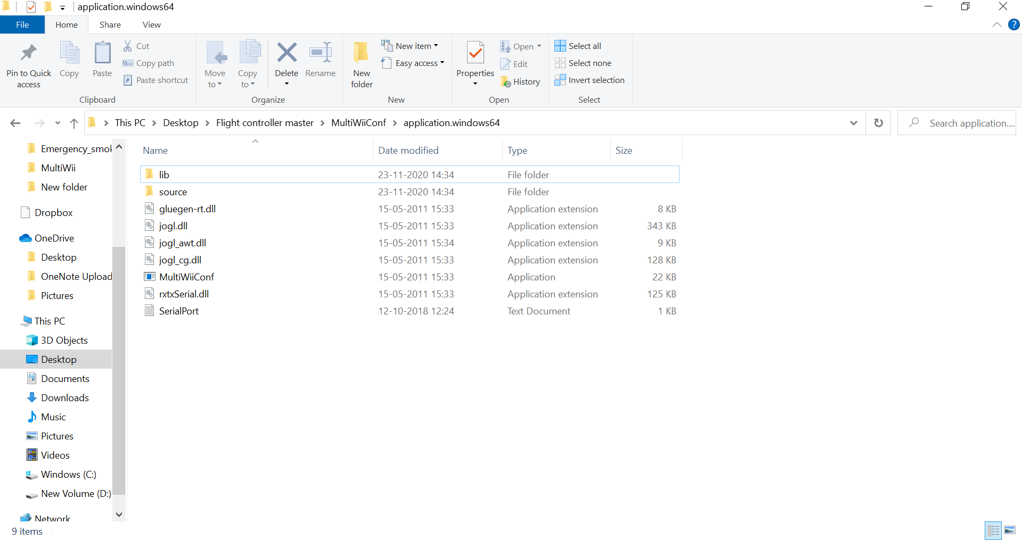

Now, choose the ‘ *MultiWii.Conf* ’ file. A window like this should open.

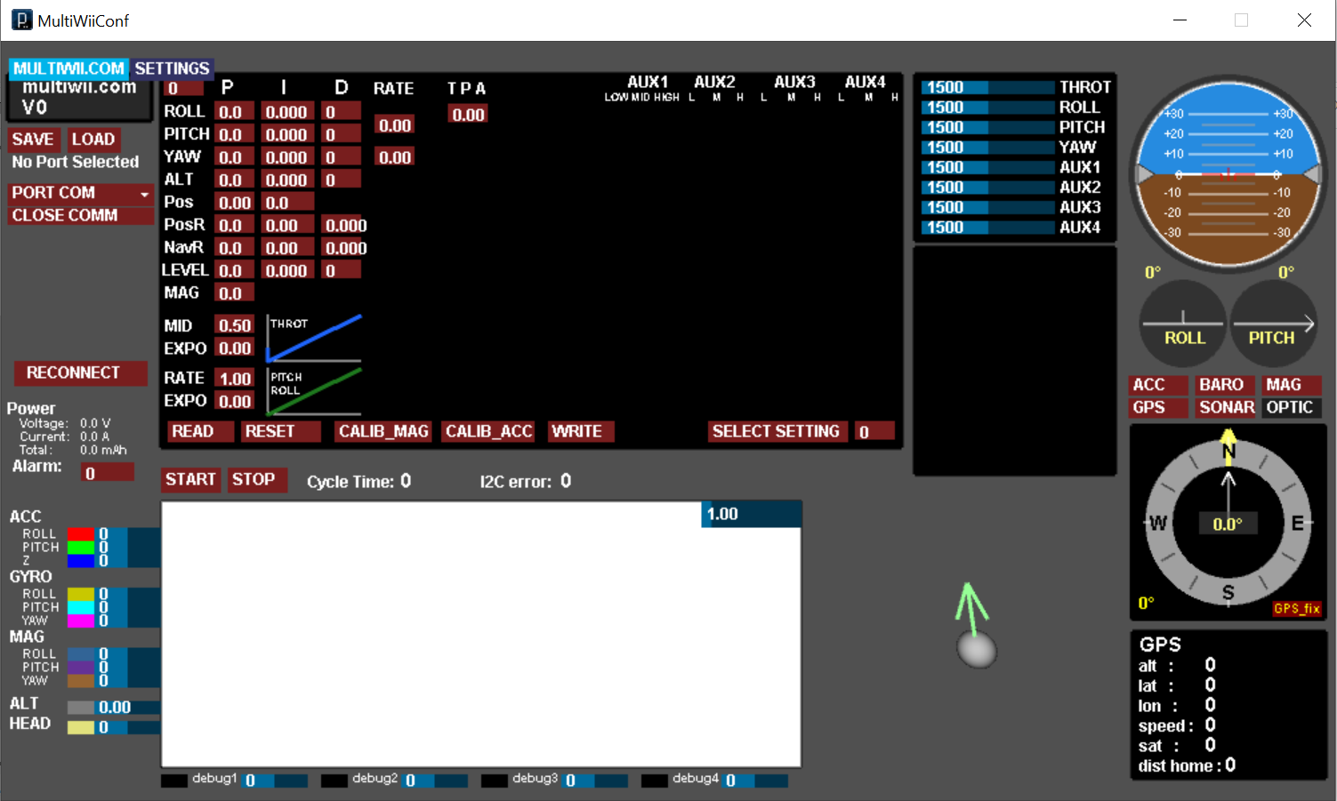

BOOM!!!

You have opened the window successfully.

Now go back to the *‘Flight controller master’* folder back again.

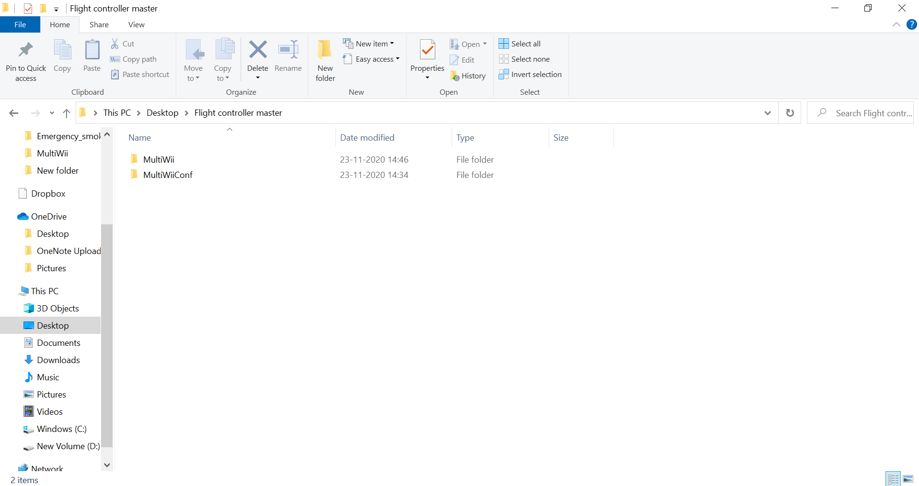

Now, open the *‘MultiWii’* folder.

Now, open the Arduino file.

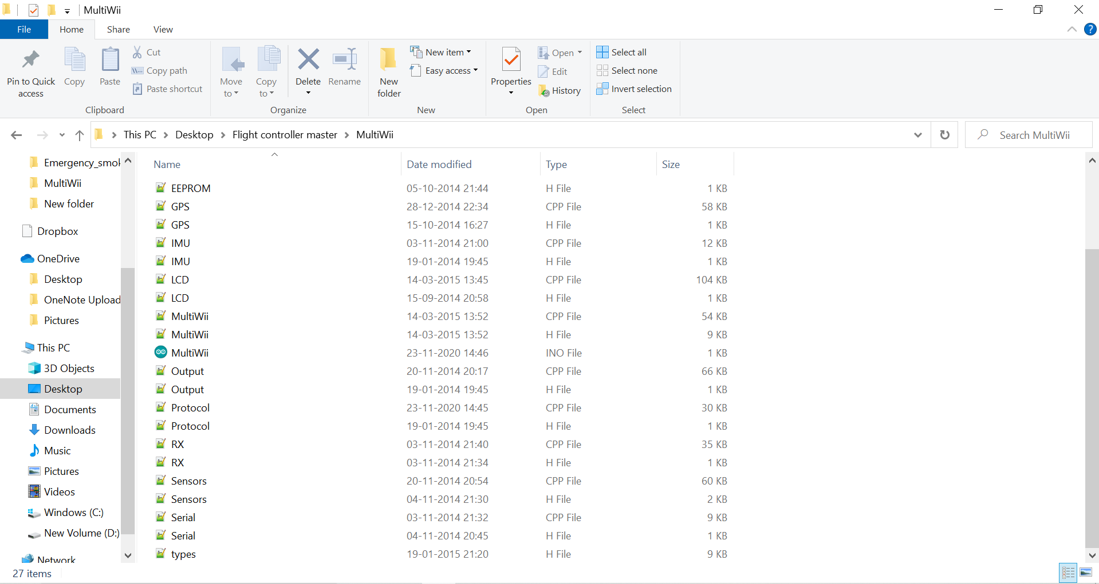

After opening it, you will land on this page of the Arduino IDE.

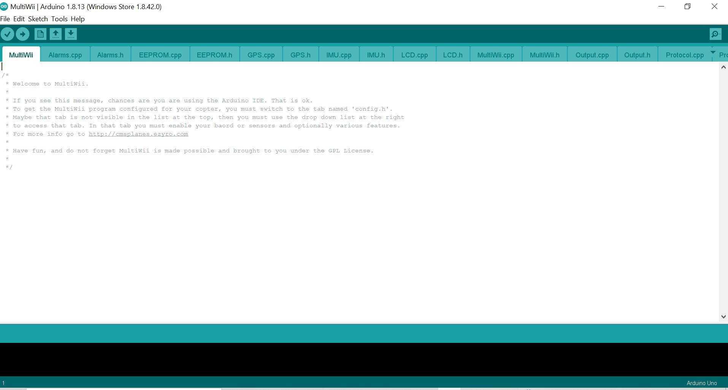

Now, plug in your Arduino module into your computer’s USB.

Then click on that, arrow to upload the codes, after selecting the correct COM and Board.

(For now select *‘Arduino nano’*.)

Now, let’s make the Circuit.

Now you can purchase a MPU 6050 from [here.](https://robu.in/product/mpu-6050-gyro-sensor-2-accelerometer/)

Please follow this circuit diagram to make the circuit.

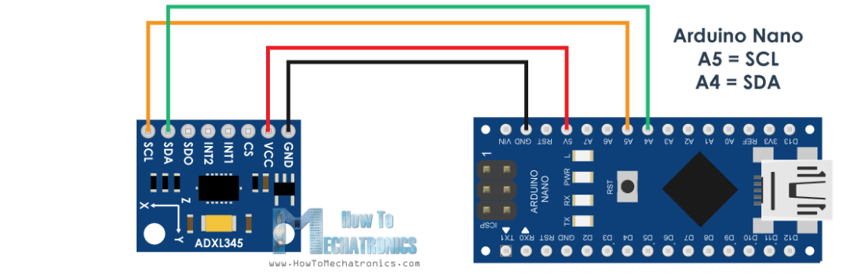

After this go back to the app and select the correct COM and Board and see the magic!

However, this flight controller isn’t only limited till this only.

Some of it’s amazing features are given below.

1. GPS control.
2. LCD display.
3. Automatic landing.
4. Protocol.
5. Alarm system and many more amazing feature.

**NOTE:** When you upload the code to the Arduino, all the codes are uploaded, you just need to make the circuit and go for it, and see the magic of the AI!

Afterall it’s the time to make the circuit of the Plane.

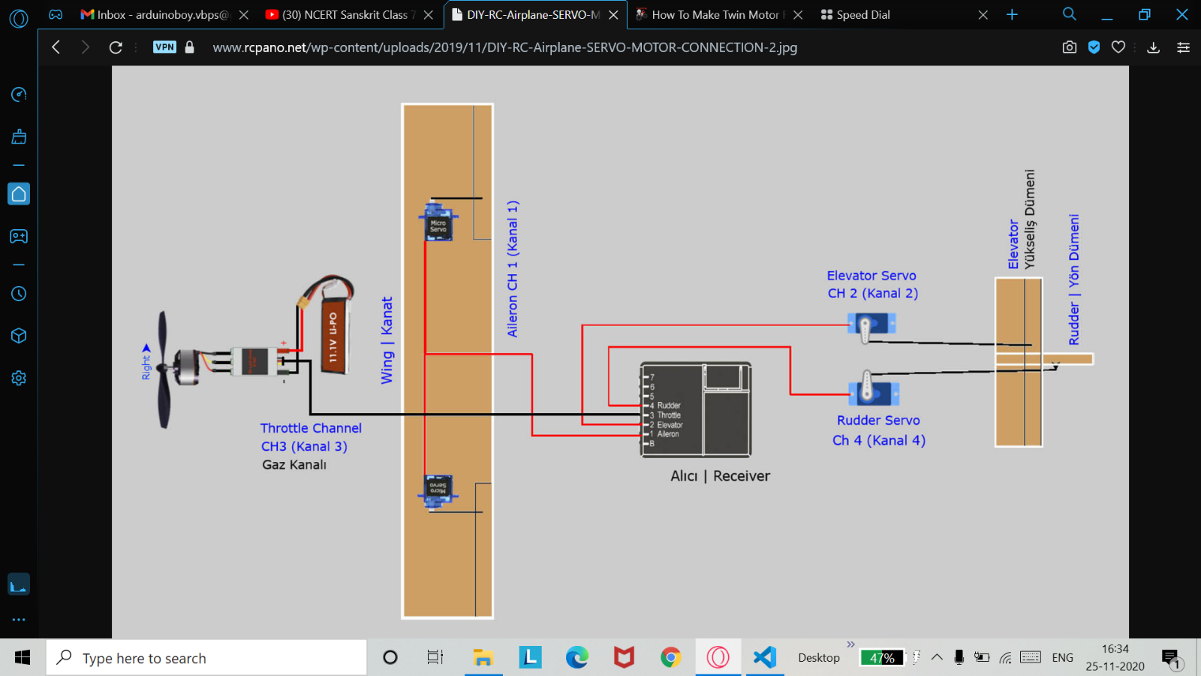

The circuit of the Plane should go something like this. ^

Thanks, from CMS community!

For any queries please visit our website.

[CMS](http://cmsplanes.ezyro.com)

The following Document is available in different languages too.

Copyright 2020 CMS planes.

*Terms and conditions apply.

The following document is made by *‘Prasoon rai’* India.